Safety Town
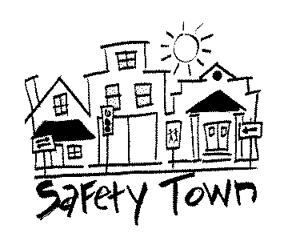

2025 our 50th year
Parks & Recreation Dept.
‘Teen Instructor’ Application

Check any session(s) you want to be part of (If more than one, prioritize #1, #2 & #3)

Session #1: July 14 – 18 _____ Volunteer Times: 8:30am-Noon On first day be there by 8:15am
Session #2: July 21 – 25 _____ Volunteer Times: 8:30am-Noon On first day be there by 8:15am
Session #3: July 28 – Aug 1 _____Volunteer Times: 8:30am-Noon On first day be there by 8:15am

Placement will be given on a first come, first received, basis.
YM YL AS
AM AL AXL
Name_____________________ T-shirt size
Address_______________________________________
Phone # _____________ Cell #_________________
E-mail address _________________________________
Are you a: New Instructor this year ____ yes
Or, are you Returning in 2025 for your year
2nd 3rd 4th 5th 6th 7th

Please let us know if you might have any conflict with other activities such as driver’s ed., band, or camp so we can make things work so you can be a part of SAFETY TOWN !

Teen Instructor Signature_____________________________________

Parent/Guardian_________________________________

Phone # (if different) ____________ Cell # ____________

Parent/Guardian Signature_________________________________________

Please complete this form and return as soon as possible to:
Parks & Recreation Department, Ericksen Community Center
1401 – 11th Avenue North Clinton, IA 52732
Questions call us at 563-243-1260 Or e-mail: dorte@cityofclintoniowa.gov

